TRAINING REPORT
Female Entrepreneurs and the Application of Digital Skills in Business

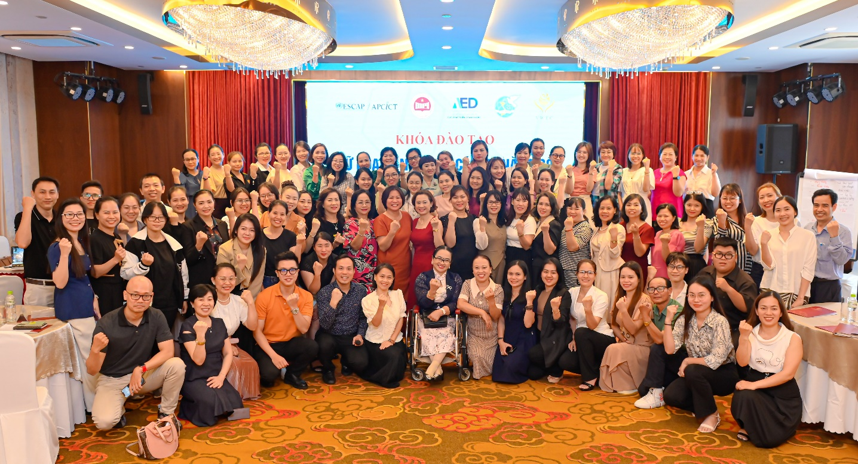

Da Nang, 27 April 2023

TRAINING REPORT
Training on Female Entrepreneurs and the Application of Digital Skills in Business

Introduction
The project “Catalyzing Women’s Entrepreneurship: Creating a Gender-Responsive Entrepreneurial Ecosystem (CWE) is implemented by the United Nations Economic and Social Commission for Asia and the Pacific (UNESCAP) and the Agency for Enterprise Development, Ministry of Planning and Investment (AED-MPI). This program is funded by the Canadian government. It aims to strengthen entrepreneurial ecosystems for women to effectively start-up and expand their businesses, enhance women entrepreneurs’ access to capital through innovative financial mechanisms, and increase women entrepreneurs’ use of ICT through relevant training and tools. This training course is an activity of this project.
Objective of the training:
- To provide women entrepreneurs and business owners with the basic ICT skills and knowledge to grow their businesses and compete in today's digital economy.
- To promote gender equality and empower women-led SMEs and household-owned businesses to access and use technology to enhance their productivity, efficiency, and profitability.
- To enhance entrepreneurship and support the development of a vibrant and inclusive private sector in Vietnam by equipping women with the digital skills and knowledge to start and grow successful businesses.
- To strengthen the capacity of women-led SMEs and household-owned businesses to engage with customers and suppliers online, expand their customer base, and access new markets.
- To promote sustainable economic development and poverty reduction by supporting the growth and success of women-led businesses, which are an essential driver of economic growth in Vietnam.
On April 27, 2023, in Da Nang, the Ministry of Planning and Investment, the Agency for Enterprise Development (AED), in collaboration with the United Nations Economic and Social Commission for Asia and the Pacific (UN ESCAP), the Vietnam Women's Union, and the Vietnam Women Entrepreneurs Council, organized a training course called "Women Entrepreneurs and Applied Digital Skills in Business" as part of the project " Catalyzing Women’s Entrepreneurship: Creating a Gender-Responsive Entrepreneurial Ecosystem (CWE). The training course provided more than 100 female entrepreneurs with basic knowledge and information about artificial intelligence (AI) and ChatGPT in business development, as well as tips on making short videos to attract customers.
Overall, the Female Entrepreneurs and the Application of Digital Skills in Business training course in Da Nang is an essential initiative that can help to promote gender equality, foster economic growth, and enhance entrepreneurship by providing women in Da Nang area with the necessary ICT skills and knowledge to succeed in today's digital economy.

Opening section

Opening remarks by Ms. Trinh Thi Huong, Deputy Director of AED-MPI
Ms. Trinh Thi Huong, Deputy Director of the Agency for Enterprise Development and Project Director of CWE" opening of the seminar. She said that this is a program specially designed for female entrepreneurs in the Da Nang region. Da Nang is a rapidly developing city with numerous business opportunities and great potential. Dynamic female entrepreneurs in Da Nang and the surrounding areas are becoming an important part of the economic development of the region and Vietnam. In this course, female entrepreneurs will learn about the essential elements of technology operations in businesses, how to research the market using free online tools, and business thinking on digital platforms. In particular, the course will emphasize the application of artificial intelligence (AI), such as ChatGPT, in business development for female-led enterprises, including writing attractive headlines and communicating about their products and services.
According to Ms. Trinh Thi Huong, The AED is implementing several projects to support female entrepreneurs, including the CWE project, with the spirit of supporting and empowering women in the business world. These initiatives aim to provide the necessary resources, training, and mentorship to help female entrepreneurs overcome challenges and thrive in their respective industries.
Through the CWE project and similar programs under the Agency for Enterprise Development seeks to foster a supportive environment that encourages female entrepreneurs to innovate, take risks, and pursue their business goals. By focusing on areas such as digital skills, market research, and artificial intelligence, these initiatives are designed to equip female entrepreneurs with the tools they need to stay competitive in today's rapidly evolving business landscape.
Ultimately, the goal of these programs is to promote gender equality in the business world and contribute to the overall economic growth and development of the region and Vietnam as a whole. By empowering female entrepreneurs and providing them with the resources and support they need to succeed, the Agency for Enterprise Development hopes to create a more inclusive and diverse business ecosystem that benefits female entrepreneurs.

Opening remarks by Ms. Mai Thi Dieu Huyen, Vice President of the Vietnam Women Entrepreneurs Council.
Following Ms. Trinh Thi Huong's remarks, Ms. Mai Thi Dieu Huyen, Vice President of the Vietnam Women Entrepreneurs Council under VCCI, delivered an opening speech, Huyen said stating that Vietnam's digital economy is growing rapidly and is increasingly becoming an important part of the national economy. Vietnam currently ranks third in the ASEAN region in terms of digital economy size. Digital technology has also been widely applied in various industries, agriculture, and services in Vietnam.
Ms. Huyen also mentioned that a quick survey on digital transformation among micro, small, and medium-sized enterprises led by women, conducted by the Vietnam Women Entrepreneurs Council in March 2021, revealed that almost all women-led micro, small, and medium-sized enterprises (99% of those surveyed) were interested in investing in technological initiatives to boost their business activities. However, they were still struggling with implementation, choosing suitable technological solutions, and identifying breakthroughs, steps, and rules for digital transformation. Only 18.45% of the surveyed enterprises had integrated digital transformation into their business development strategies, while 17.5% used technology to automate core activities such as purchasing, and inventory management, and 30% applied IT software to financial, accounting, and human resource management. Although aware of the opportunities and benefits of digital transformation, women-led MSMEs still face many challenges and difficulties, such as a lack of understanding, knowledge, and skills in digital transformation, and limitations in financial resources and technical personnel.
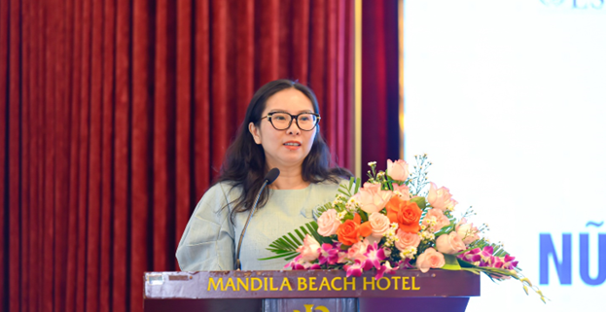
Ms. Mai Thi Dieu Huyen, Vice Chairwoman of the Vietnam Women Entrepreneurs Council

According to Ms. Huyen, in recent years, the Agency for Enterprise Development has always been working closely with the Vietnam Women Entrepreneurs Council and various business associations to support anaaaaaad promote digital transformation in women-led enterprises, as well as enhance the capacity of female entrepreneurs. The CWE project, funded by UNESCAP and implemented since 2020, has contributed to improving the capacity for digital technology applications for female entrepreneurs and women start-ups. The Vietnam Women Entrepreneurs Council is hopeful that with the timely technical assistance, precise objectives of the CWE project, and close cooperation between the AED and multiple business associations, including the Vietnam Women Entrepreneurs Council under VCCI, they can foster a nurturing ecosystem for women-led enterprises in Vietnam. This effort will ultimately contribute to increasing the competitiveness of women-led businesses across the nation, in line with the project's mission of "Catalyzing Women’s Entrepreneurship: Creating a Gender-Responsive Entrepreneurial Ecosystem."

Training sessions
Training Methodology: The training methodology consisted of presentations (lectures), case studies, group work, open discussions, brainstorming exercises, and experience sharing. Also, additional complimentary materials were prepared in the form of handouts and distributed. In the end, an online evaluation questionnaire was posted in order to evaluate the training results and its success amongst the participants as well.

Training orientation - Dr. Duong Thi Kim Lien
- Explained rules and working principles for the training session
- Presented overview and summary of the training

ICT Training - Mr. Bui Quang Cuong, Consultant

Overview of ICT application in Women –led enterprises
- Overview of ICT activities in enterprises
- Advantages and disadvantages of applying ICT in Women- led enterprises.
- How to do market research through free digital tools

Business mindset on digital platforms
- Evaluate the current digital assets of the enterprise.
- Things to know for effective online business on e-commerce platforms.
Practice: Create differentiation for the enterprise's products and services in the digital environment.

Application of Artificial Intelligence (AI) and ChatGPT in Business Development for Women –led Business.
- 101 effective ways to write headlines for articles.
- Important rules in image design
- Applying AI & ChatGPT in content writing and image designing
Tips for making short videos that attract viewers on social media platforms (TikTok, Facebook, YouTube, Instagram)
- 6 common types of videos that attract viewers
- How to create a script for a short video
- Tips for filming and editing videos using a smartphone
Practice: Apply AI and ChatGPT to create short videos for businesses.

Closing remarks
Dr. Duong Thi Kim Lien appreciated the time and effort of participants from Da Nang and other provinces and expressed positive anticipation for future opportunities to work with Da Nang Province DPI and other neighboring provinces to conduct more training.

CONCLUSIONS AND FOLLOW-UP ACTIONS
- The event was conducted successfully according to the agenda with good compliments from attendants.
- Continues to support WSMEs in improving their capabilities such as coaching, mentoring them.

MEL REPORT
Post-training Evaluation
After finishing the training, each participant was asked to fill out the post-training evaluation forms to provide information about the organizational type and show their level of agreement with the opinion.
According to the chart of the results obtained from the online survey, 93% of the students came from the private sector, 2.8% of the students were from government and academic institution, and 1.4% of the students were from international organizations.
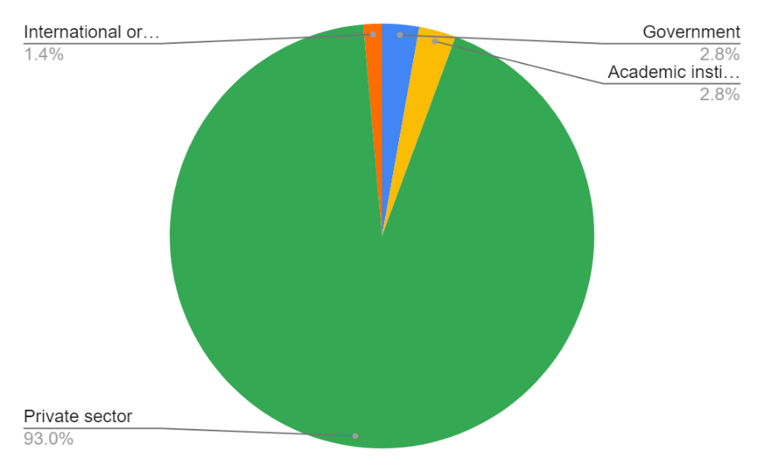

The program 'Female Entrepreneurs and the Application of Digital Skills in Business' received participation and response from female entrepreneurs, with a ratio of 84.5% female participants.
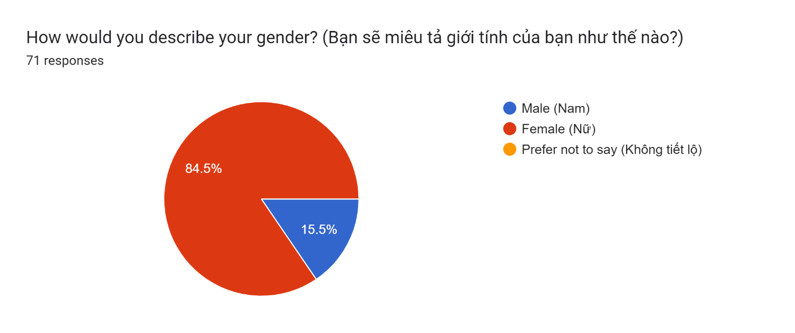
The evaluation uses the scale from 1-5, with 1 being “strongly disagree”, 2 being “disagree”, 3 being “neutral”, 4 being “agree” and 5 as “strongly agree”. Regarding the first question of survey online, 74.6% of the respondents strongly agreed and 22.5% agreed that 'Through this training, my awareness and understanding of this topic has increased'. Additionally, only 2.8% of the respondents were neutral.
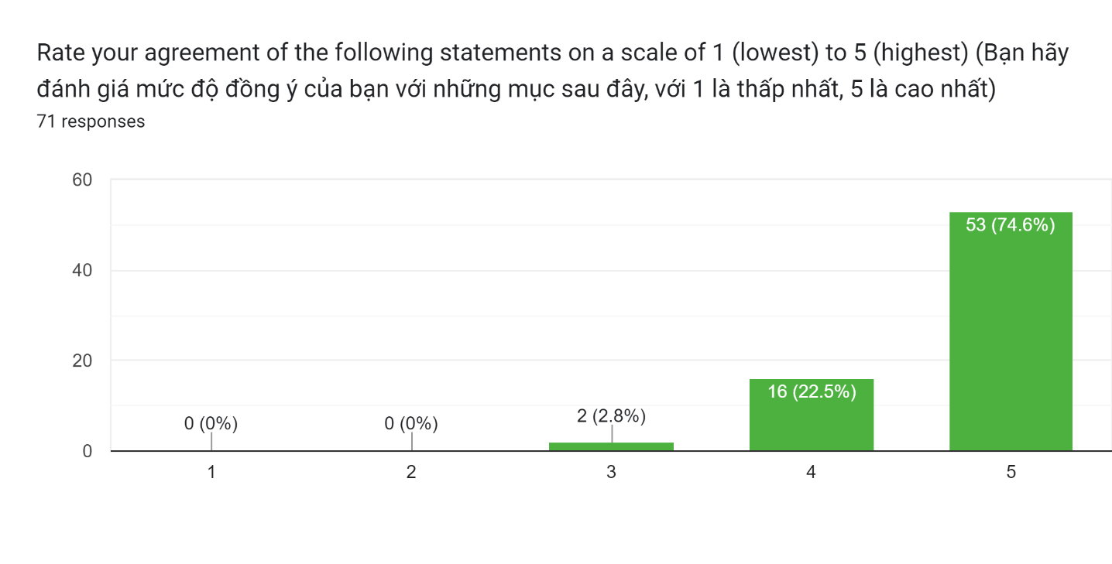
Proceed to the second evaluation question, 76.1% of the respondents strongly agreed and 18.3% agreed that “I will apply what I learned in this training in my business”.
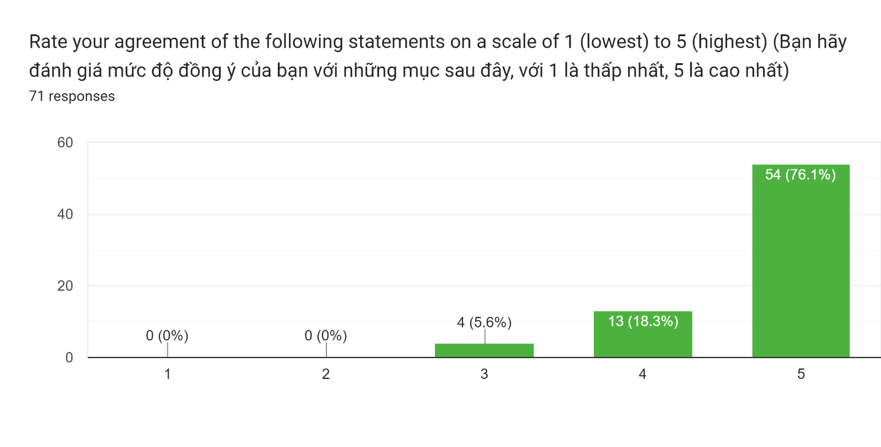

Regarding the third survey question, 73.2% of the respondents strongly agreed and 23.9% agreed that “I will apply what I learned in this training in my business”. No respondents disagreed or strongly disagreed.
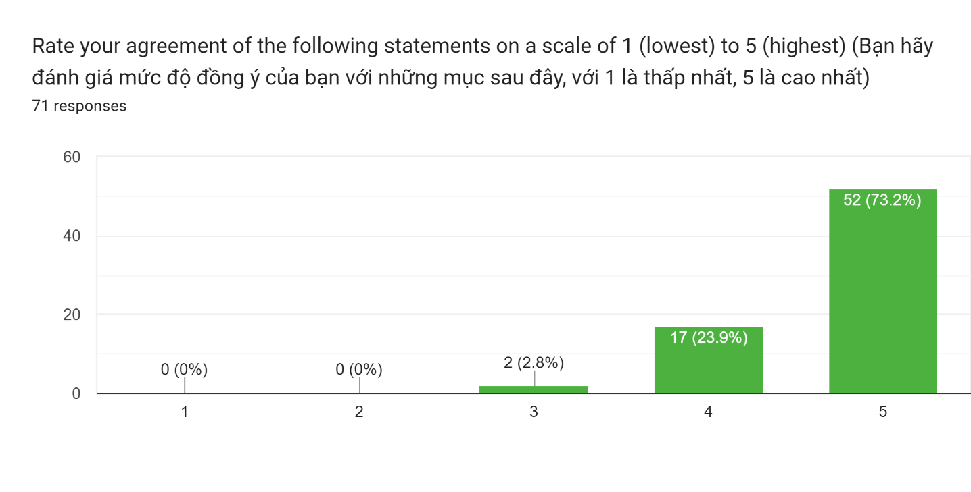

According to the chart of the results obtained from the online survey, 67.6% of the respondents strongly agreed and 29.6% agreed that “The course met my expectations”. No respondents disagreed or strongly disagreed.
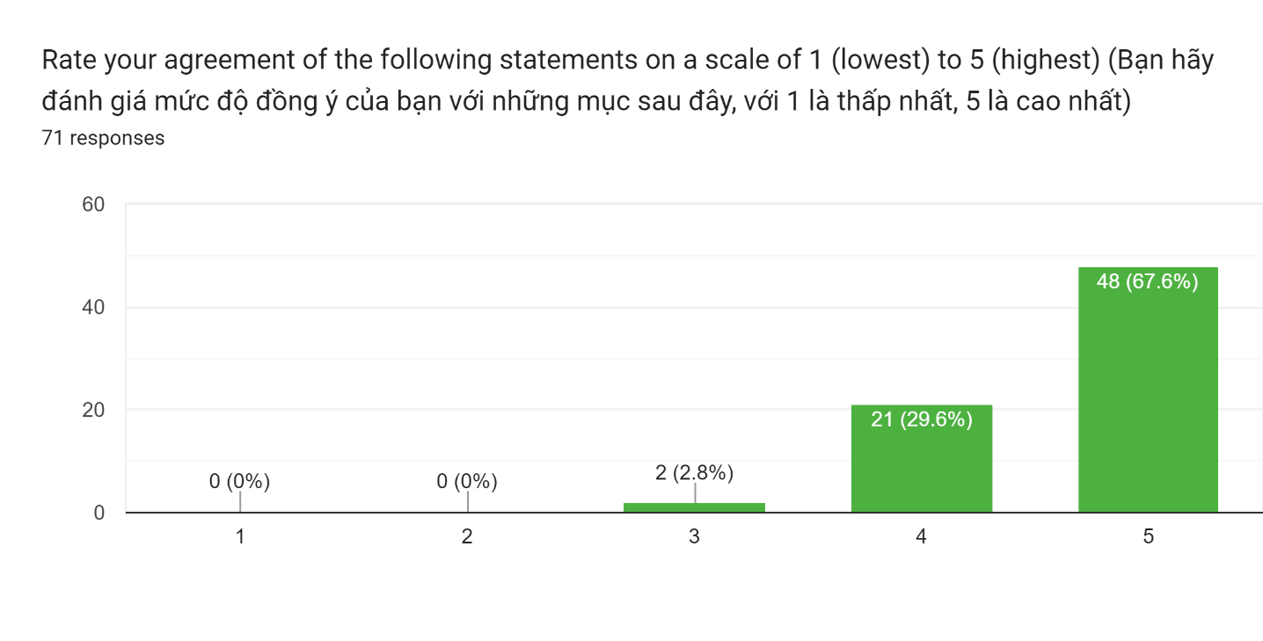

According to the results obtained from the online survey, 76.1% of the respondents strongly agreed and 22.5% agreed that “The scope of the training was appropriate”. Additionally, only 1.4% of the respondents were neutral. No respondents disagreed or strongly disagreed.
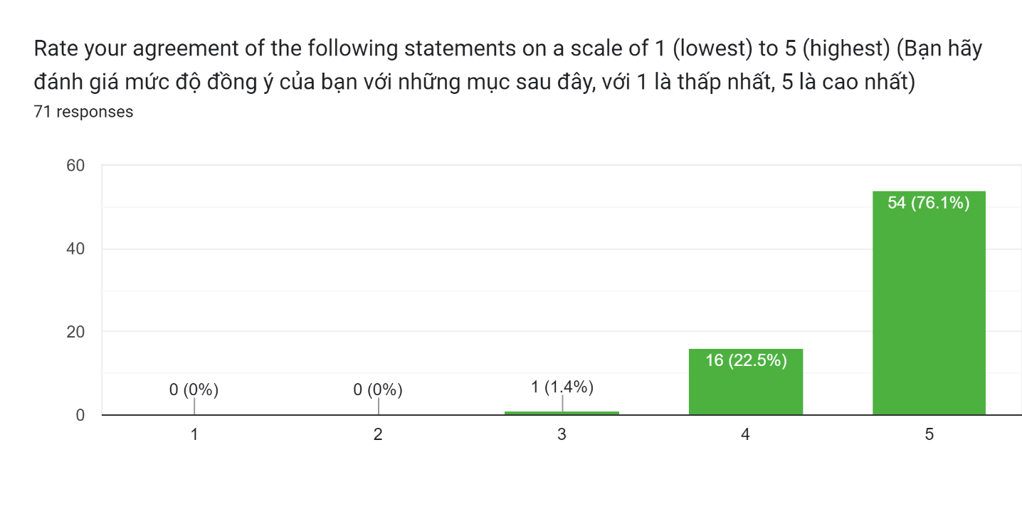

Regarding the next survey question, 62% of the respondents strongly agreed and 36.6% agreed that “The training met its objectives”. Additionally, only 1.4% of the respondents were neutral. No respondents disagreed or strongly disagreed.
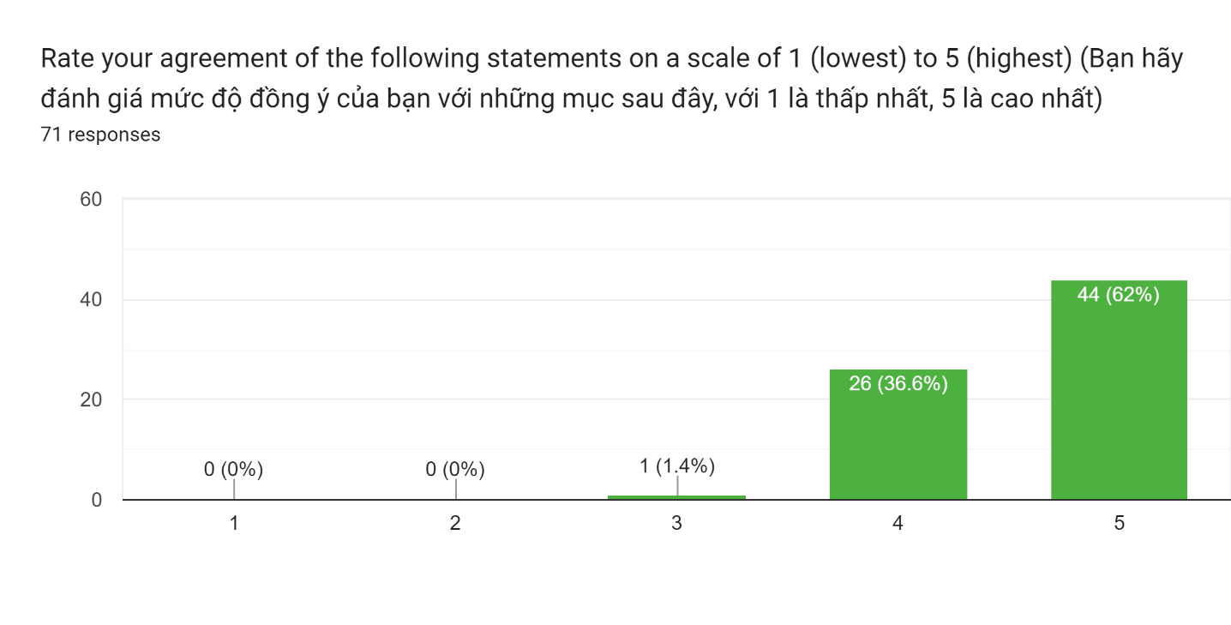

Regarding the next survey question, 71.8% of the respondents strongly agreed and 25.4.6% agreed that “The materials (course content, modules) were appropriate and effective”. Additionally, only 2.8% of the respondents were neutral. No respondents disagreed or strongly disagreed.
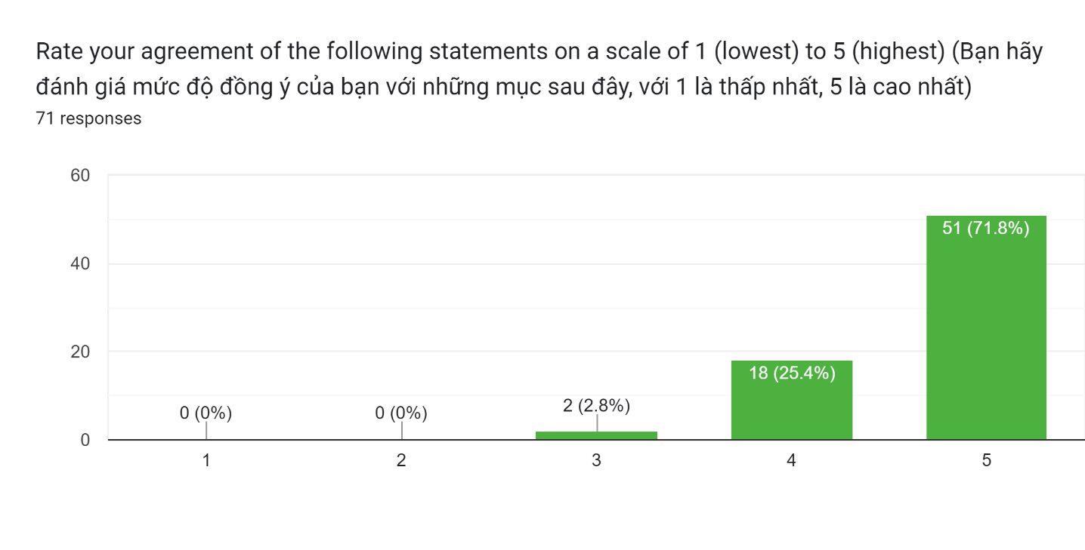
Up to 80,3% of the respondents completely agreed that “The delivery approach and method were appropriate and effective”.
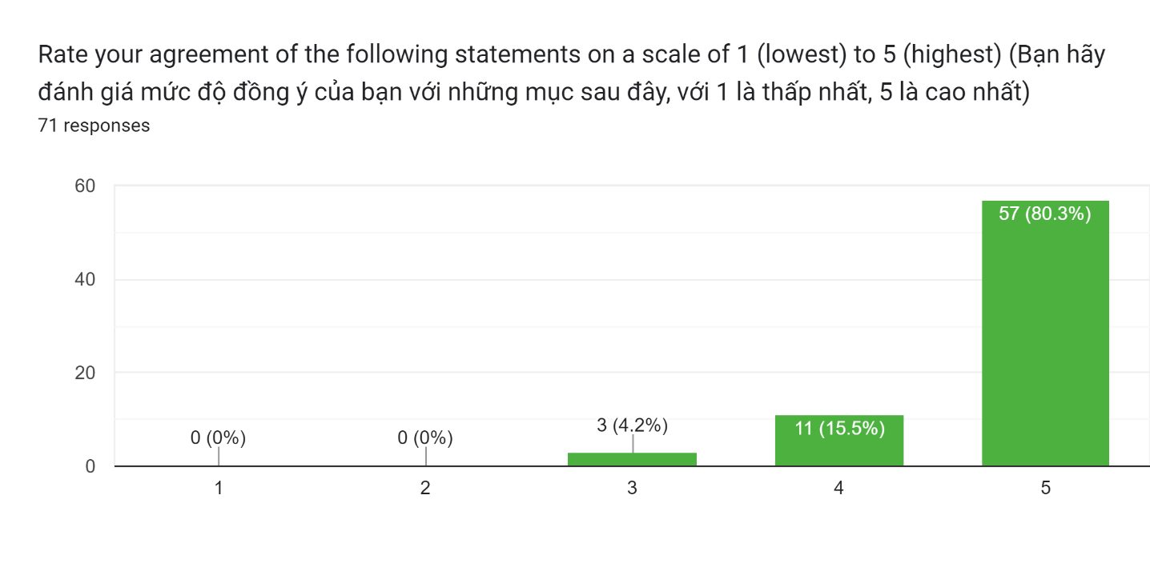
According to the results obtained from the online survey, 74.6% of the respondents strongly agreed and 21.1% agreed that “Administrative and logistical arrangement was efficient (Overall satisfaction. No respondents disagreed or strongly disagreed.
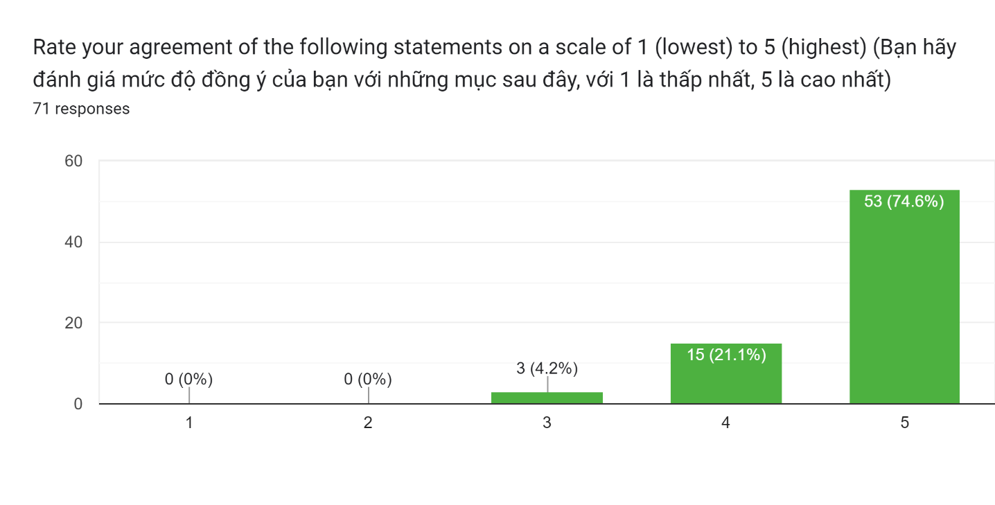

The following table shows the results from the post-training survey, evaluated by the participants
 | Question topics | Mean | Min | Max
1 | Through this training, my awareness and understanding of this topic has increased | 4.7 | 3 | 5
2 | I will apply what I learned in this training in my business | 4.7 | 3 | 5
3 | The course met my expectations | 4.7 | 3 | 5
4 | The scope of the training was appropriate | 4.6 | 3 | 5
5 | The training met its objectives | 4.7 | 3 | 5
6 | The materials (course content, modules) were appropriate and effective | 4.6 | 3 | 5
7 | The delivery approach and method were appropriate and effective | 4.6 | 3 | 5
8 | The activity was delivered in a timely manner according to plan | 4.7 | 3 | 5
9 | Administrative and logistical arrangement was efficient | 4.7 | 3 | 5

Besides the rating on level of agreement in the opinion, participants were asked to give comments and suggestions for future training or any needed improvements. In general, participants would like the future training courses should have more practices and examples, extend the training period, provide more work groups, team-building games and provide more details and a wide range of in-depth teaching content.
Advantages:
- The training was held in good conditions, all materials and lectures were well prepared in advance.
- Participant paid attention to the lectures and actively participated in the discussion during a course.
- There was a significant improvement in terms of the basic knowledge and understanding of participants.
- The teacher effectively communicates the knowledge in an understandable and practical manner. The learned knowledge and content are significant, relevant, and useful.
Disadvantages:
- The training was conducted in a short time duration so that participants would like to extent the training period to gain more knowledge and a wide range of in-depth teaching content.
- Because of limited time, the progame was absence of fun – creating games or ice-breaking exercises.

Annex 1. Training agenda
Time | Activities
08:30 – 09:00 | Welcome & register for delegates to attend classes. AED
09:00 - 09:05 | Statement of reasons, introduction of the delegates  CWE
09:05 - 09:20 | Open speech:  Ms. Trinh Thi Huong, Deputy Director of Agency for Enterprise Development (AED), Ministry of Planning and Investment  Ms. Mai Thi Dieu Huyen, Vice Chairwoman of Vietnam Women Entrepreneurs Council VCCI (VWEC)
09:20 – 10:30 | Overview of ICT application in Women –led enterprises  - Overview of ICT activities in enterprises  - Advantages and disadvantages of applying ICT in Women- led enterprises.  - How to do market research through free digital tools  Mr. Bui Quang Cuong
10:30 - 10:45 | Tea break
10:45 - 12:00 | Business mindset on digital platforms  - Evaluate the current digital assets of the enterprise.  - Things to know for effective online business on e-commerce platforms.  Practice: Create differentiation for the enterprise's products and services in the digital environment.  Mr. Bui Quang Cuong
12:00 - 13:30 | Lunch break
13:30 – 14:45 | Application of Artificial Intelligence (AI) and ChatGPT in Business Development for Women –led Business.  - 101 effective ways to write headlines for articles.  - Important rules in image design  - Applying AI & ChatGPT in content writing and image designing  Mr. Bui Quang Cuong
14:45 – 15:00 | Tea break
15:00 - 16.50 | Tips for making short videos that attract viewers on social media platforms (TikTok, Facebook, YouTube, Instagram)  - 6 common types of videos that attract viewers  - How to create a script for a short video  - Tips for filming and editing videos using a smartphone  Practice: Apply AI and ChatGPT to create short videos for businesses.  Mr. Bui Quang Cuong
16.50 – 17.00 | Summary and evaluation of the content and quality of the class.  AED, VWEC

Annex 2. Photos of training
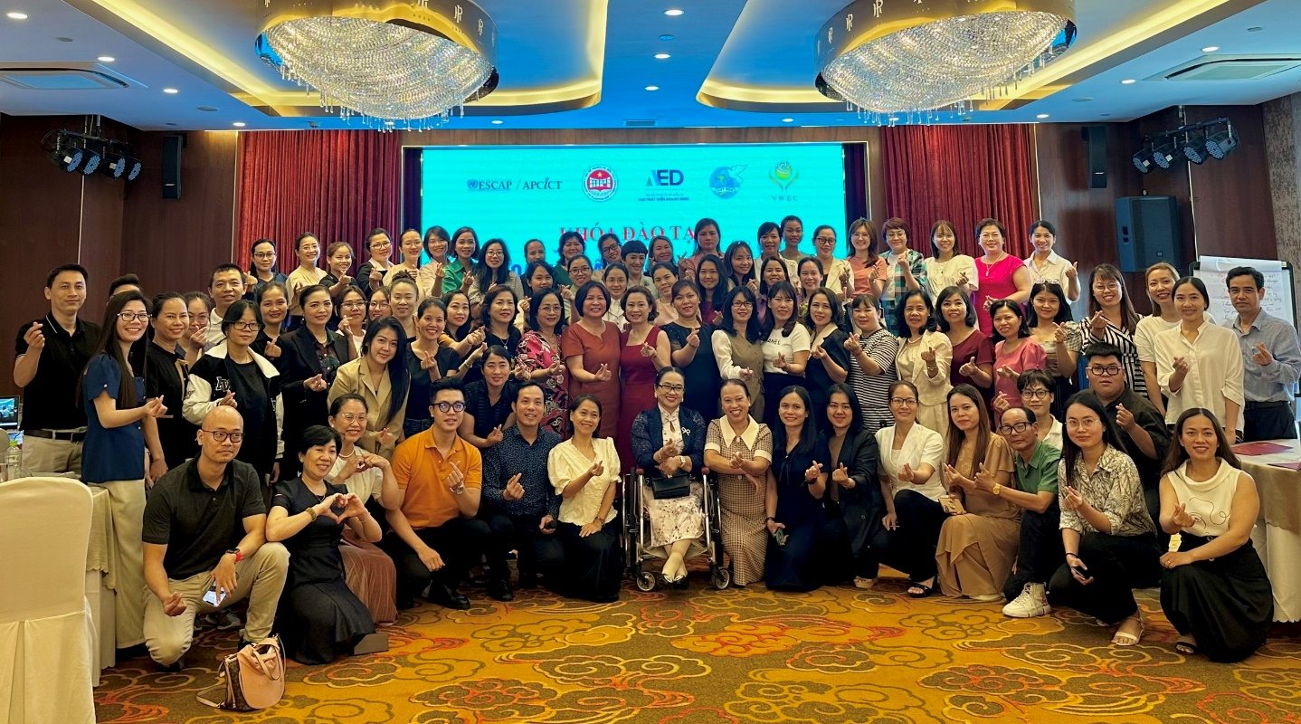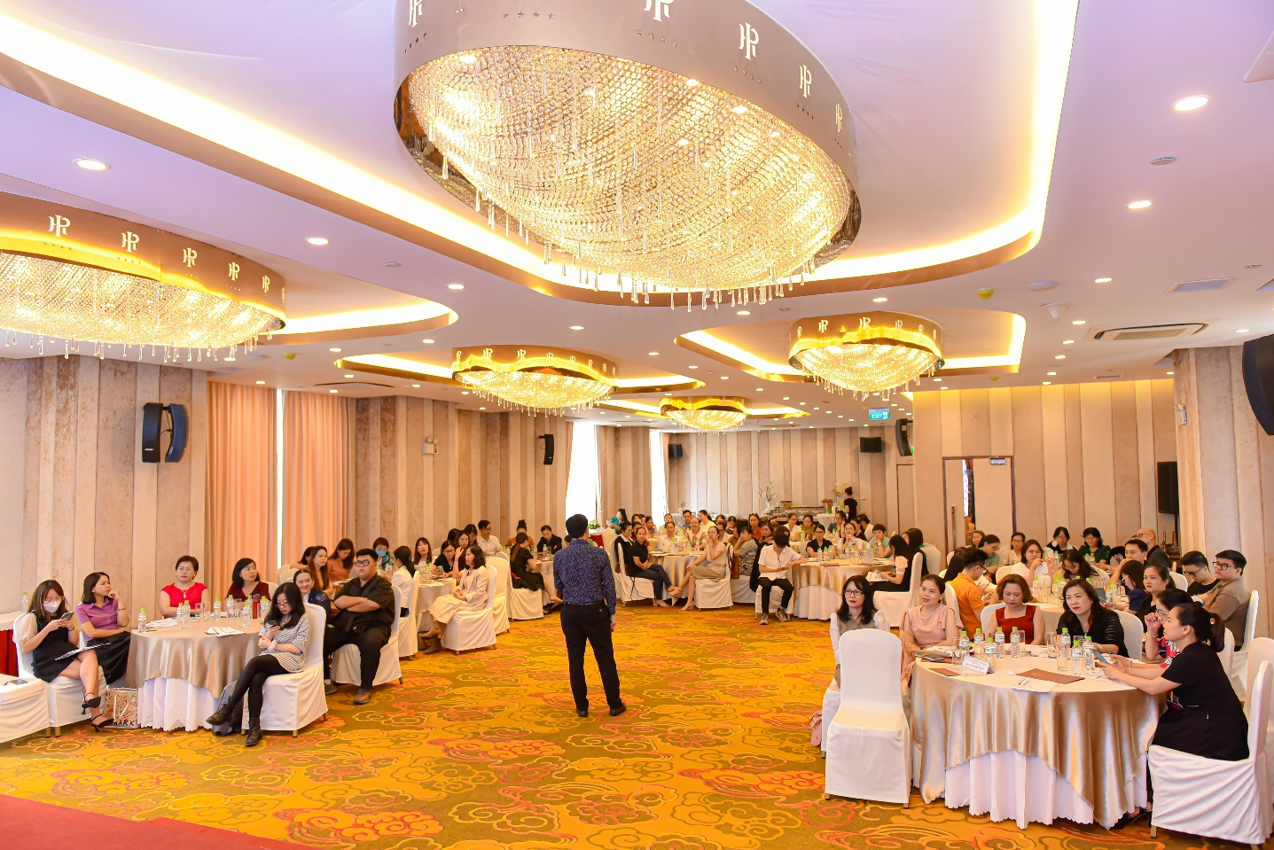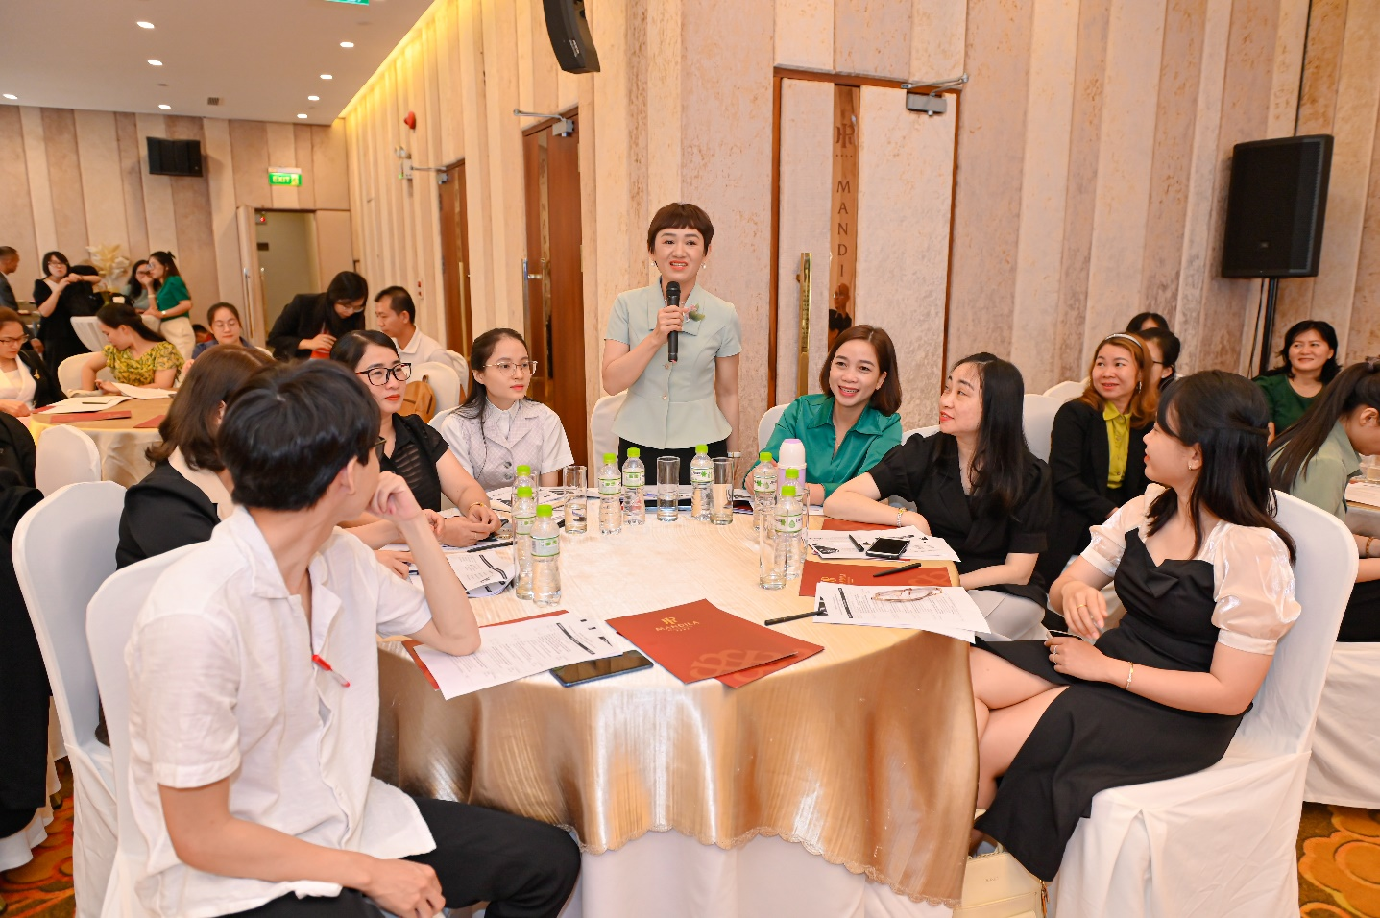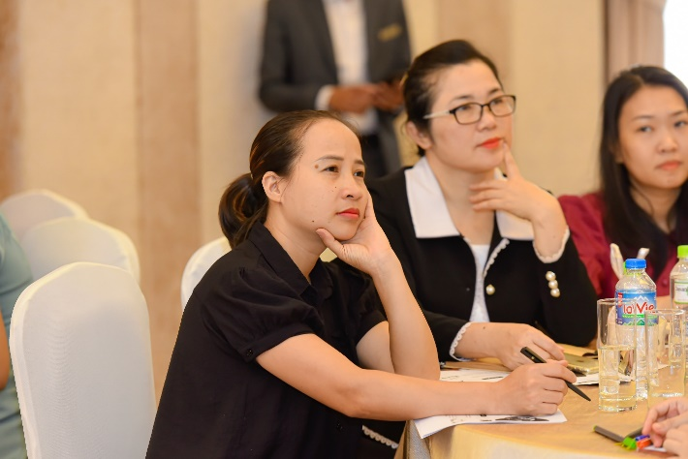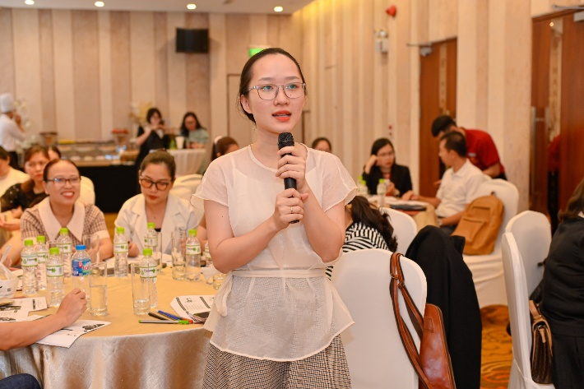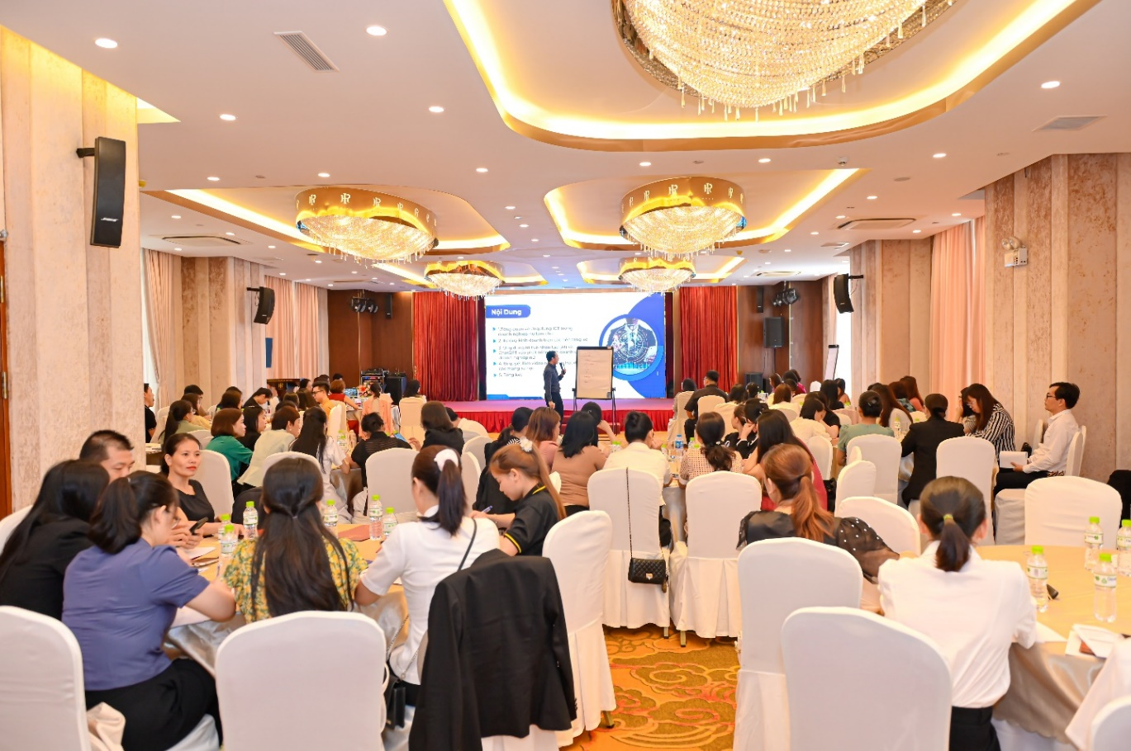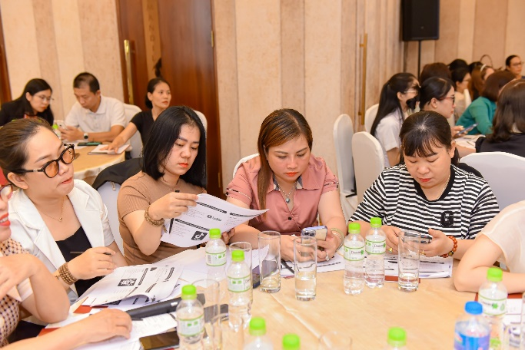
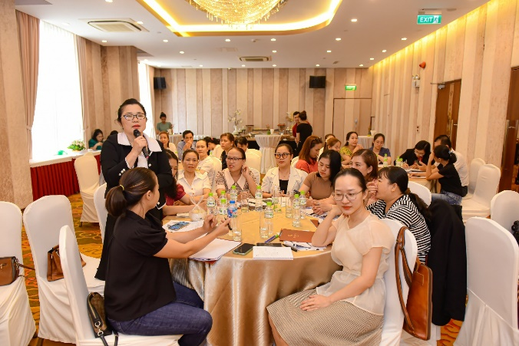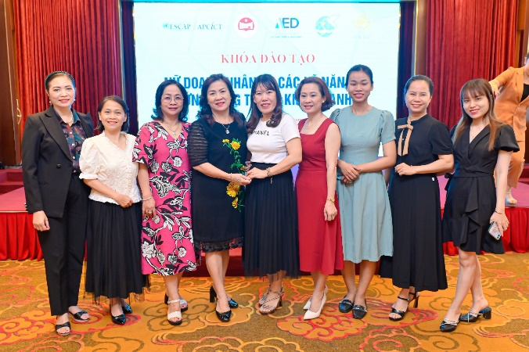
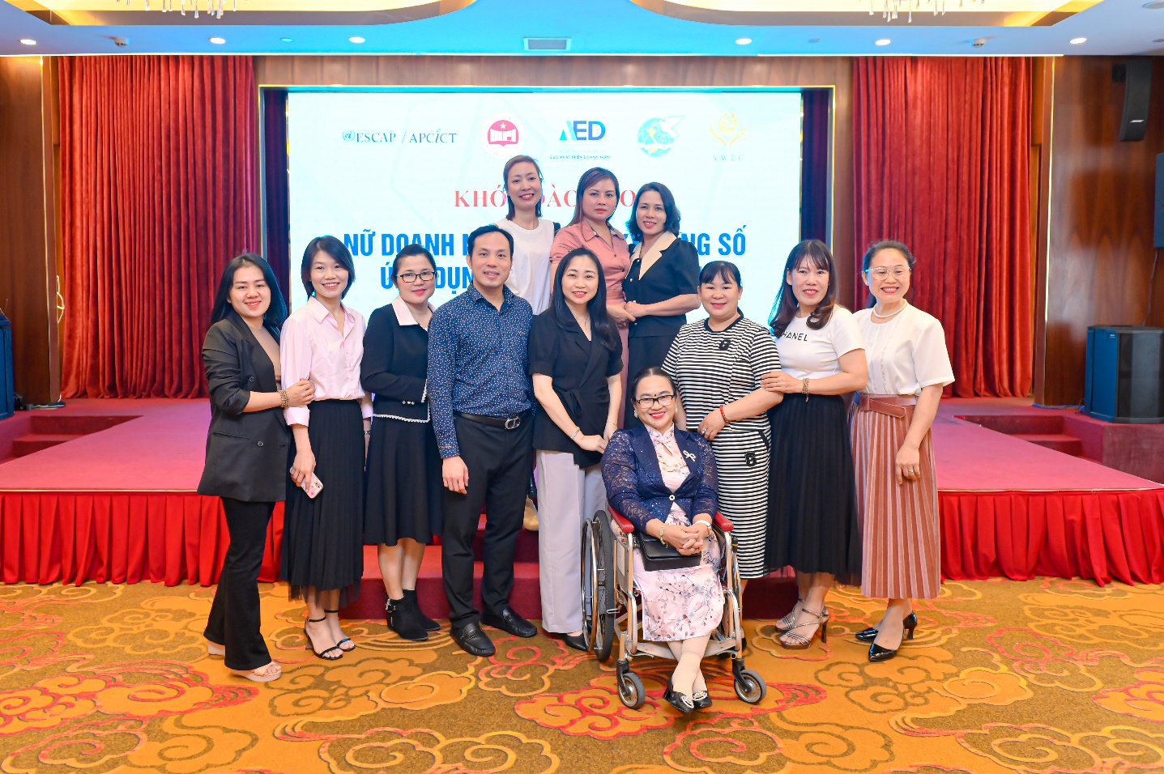
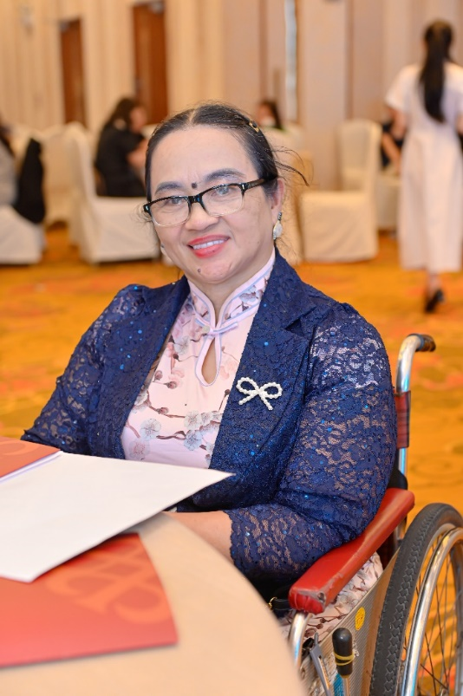

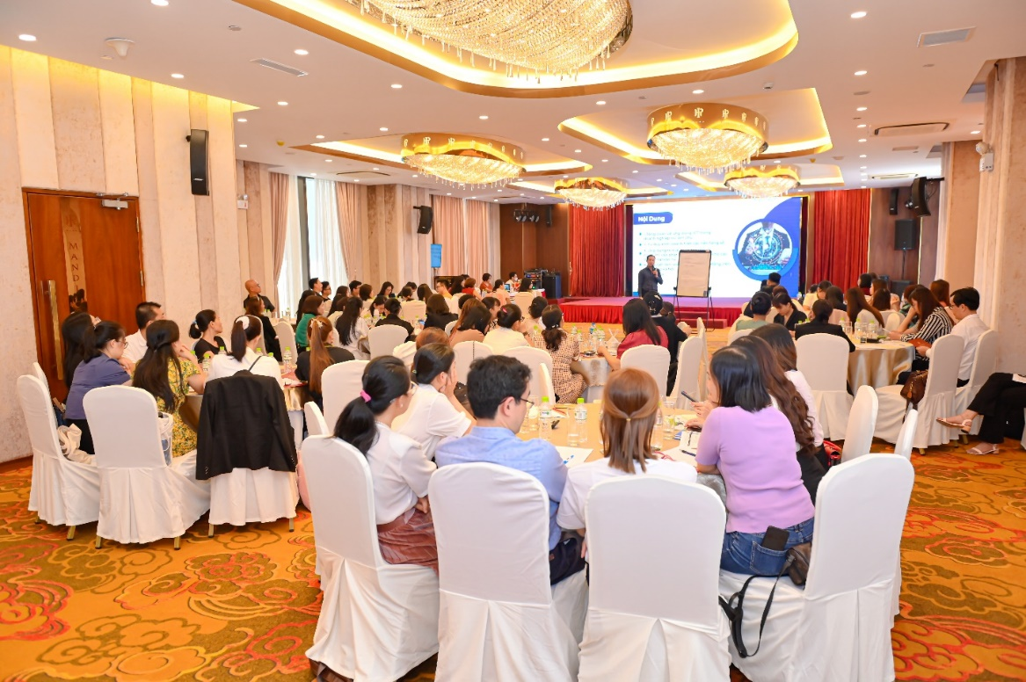

Annex 3: End of workshop questionnaire survey
https://docs.google.com/forms/d/1W9Xoxifnrnxnc2jQ9L5ja4Tt4UuXmsFmc8hM0ZqCd68/edit

Annex 4: List or participants
